HOME PAGE

Please confirm the various internet news sources for each of the news sub-headings (ie. “Companies”, “Markets”, “Economy”, “Industry”, “Regulatory”, “Guru Watch”, “North America”, etc). I want to make sure that the news being displayed for each one are relevant to the subject of the sub-headings. Some sources don’t appear to be related to investing at all (eg. Vanity Fair, Page Six, Twisted Sifter, Bleeding Cool News, etc).

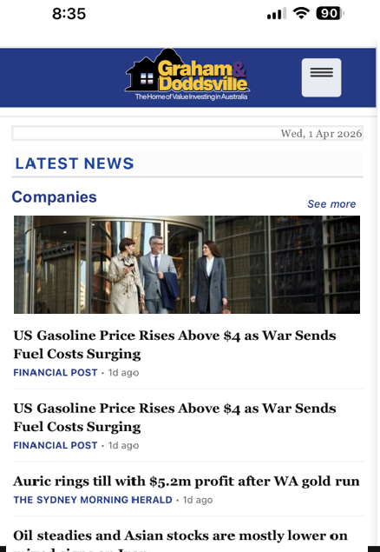
Insert an image under each sub-heading - see attached file titled “2026-04-01 Stock images for Home page” for the images to be inserted in the Home Page.

I’d prefer to see the left edge of the image level with, or reach, the left hand margin of the page (as depicted).

Please make sure that ALL images are in a low file size format so as not to negatively affect website download speed.

SECONDARY PAGES

1. Wealth Creation


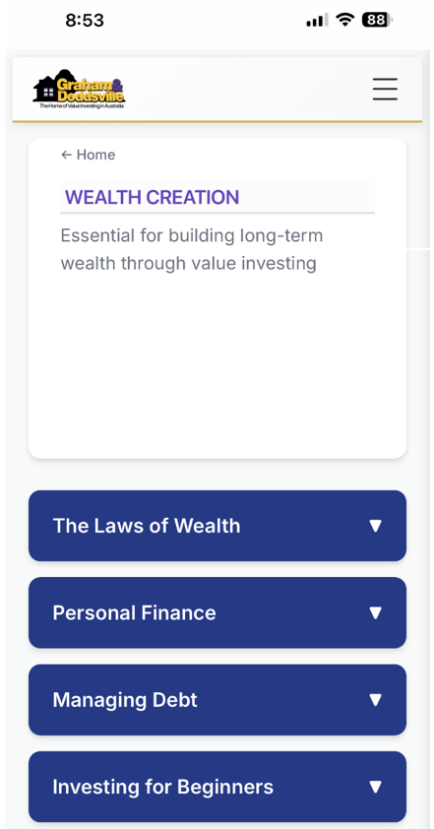
Insert an image under each tab heading - see attached file titled “2026-04-01 Stock images for Home page” for the images to be inserted in the Secondary Pages.

I’d prefer to see the left and right edges of the image level with, or reach, the left and right edges of the grey border (as depicted).

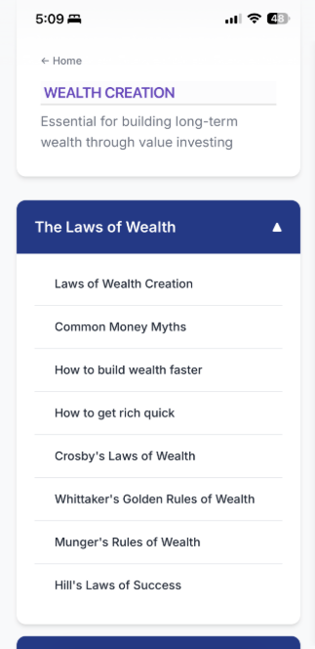
All articles need to be in an Uppercase / lowercase format. This means that:

“How to build wealth faster” should be “How to Build Wealth Faster” .

“How to get rich quick” should be “How To Get Rich Quick”.

Please check to make sure that all articles in the rest of the website are in this format.


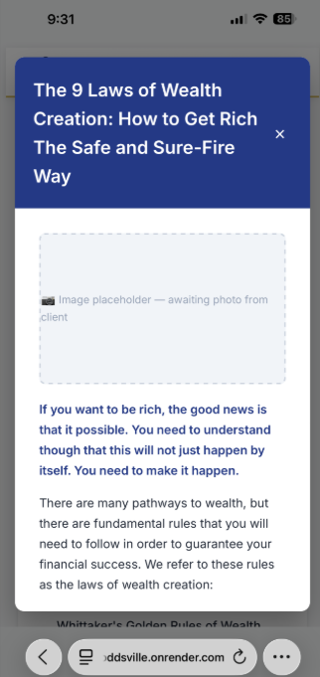
Insert an image under each article heading - see attached file titled “2026-04-01 Stock images for Home page” for the images to be inserted for the selected articles under Wealth Creation > The Laws of Wealth.

I’d prefer that the left edge of the image be level with, or reach, the left hand margin of the page (as depicted).

Note that I have not given you all of the article images at this stage. I am currently arranging for the rest of the article images to be procured and collated. I will send to you as soon as they have been fully compiled together.

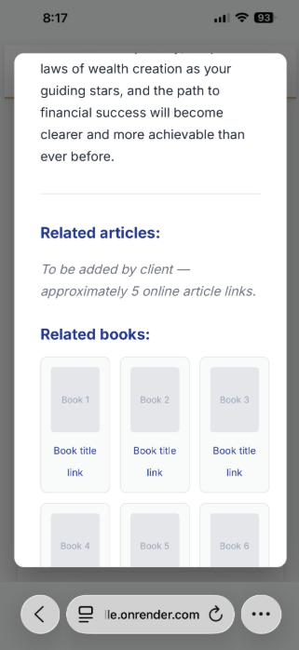
Please add these 5 articles - they should be clickable – as I want to see how this section looks like. Do not separately type the url and do not use bullet points:

The Laws of Wealth Creation: How to Build Lasting Wealth
https://www.wealthwithin.com.au/learning-centre/investing-and-wealth-creation/the-laws-of-wealth-creation

The 4 Universal Laws of Wealth Creation
https://medium.com/@CraigBallantyne/the-4-universal-laws-of-wealth-creation-follow-these-or-stay-broke-840fae18d4ae

Money: The 10 Immutable Laws Of Building Wealth
https://www.investing.com/analysis/money-the-10-immutable-laws-of-building-wealth-200675374

Proven Wealth Creation Strategies: A Beginner's Guide
https://directwealth.com.au/beginners-guide-to-wealth-creation/

Top 10 Simple Principles for Building Your Wealth
https://www.etmoney.com/learn/personal-finance/simple-principles-for-building-your-wealth/
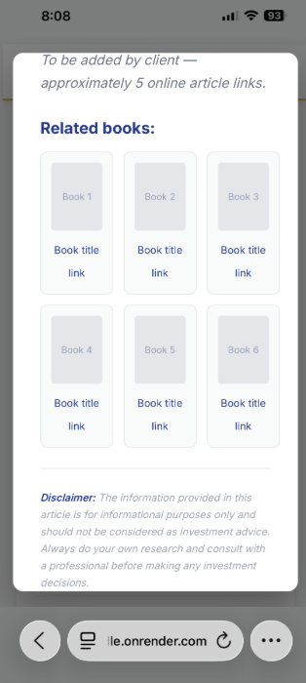
Remove “Book title” – the title on the book cover itself will be sufficient.

Also change “link” to “Buy now”.

I have also added new tabs and articles. Refer to the attached Word document – the changes have been highlighted in red. Please incorporate these changes into the website. Note that some of the highlighted are single letters (eg. converting upper case to lower case). Also note that the order of some tabs/articles have changed.

2. Legal & Taxation

See text above.

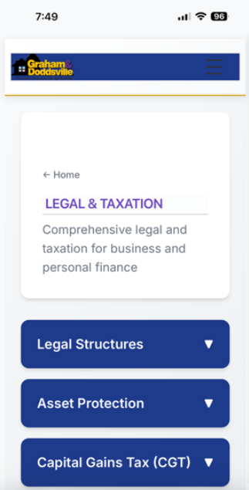
This should be white background, just like “Wealth Creation”.

3. Financial Markets

See text above.

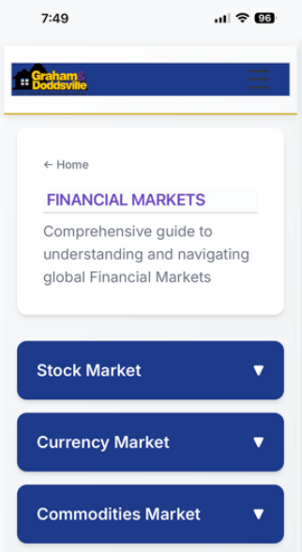
This should be white background, just like “Wealth Creation”.

4. Share Investing

See text above.

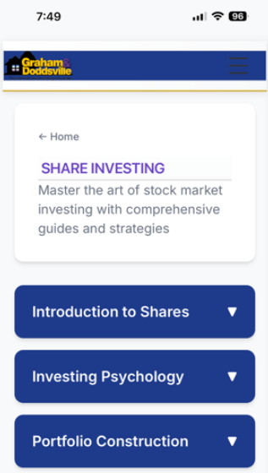
This should be white background, just like “Wealth Creation”.

5. Greatest Investors

See text above.

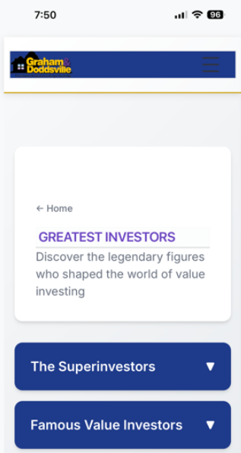
This should be white background, just like “Wealth Creation”.

6. Investment Analysis

See text above.

7. Economics

See text above.

8. Professional Advisers

See text above.

9. Financial Products

See text above.

10. Resources

See text above.

11. Events & Seminars

See text above.
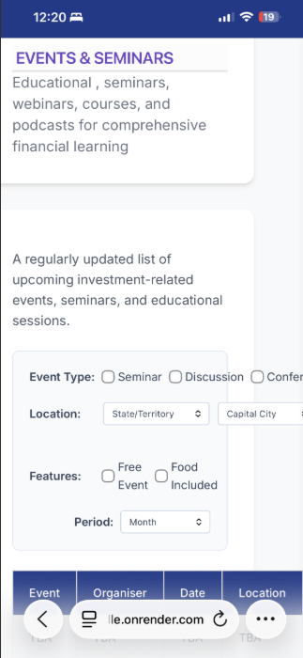
This should be white background, just like “Wealth Creation”.

The events and seminars table does not look good in portrait mode (it is in landscape mode). It needs to be in portrait format so it is easily readable on the phone.

